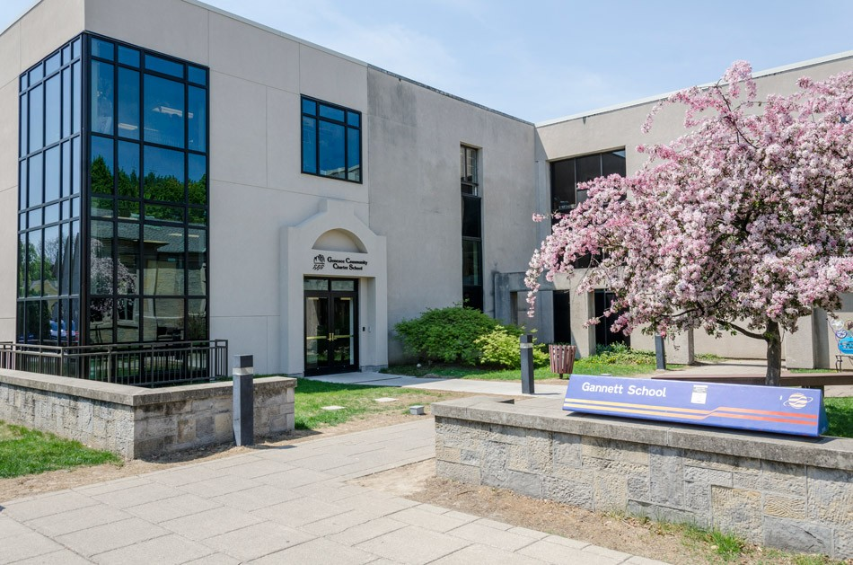

MINIMUM CAPACITY :-

The Minumum intake capacity

of students is between 300-620

children

LIBRARY :-

The Libarary is Available.

CANTEEN:-

The Canteen Facility is Available.

BOARDING :-

No availablility of boarding.

SPORTS :-

There are different categories

sports available.

Girls Volleyball

Boys Volleyball

Football

|  |  |  |
| --- | --- | --- |
| GENESEE COMMUNITY CHARTER SCHOOL  ROCHESTER - SCHOOL |  |  |
|  |  |  |
| School Detail :- Genesee Community Charter School enrolls approximately 215 students in kindergarten through sixth grade. As a charter school, Genesee Community Charter School is publicly funded and there is no tuition. Enrollment is open to all city of Rochester residents, and a lottery is held in April of each year for incoming kindergarten students and for vacancies as they are available in first through fifth grades.  Genesee Community Charter School enrolls approximately 215 students in kindergarten through sixth grade. As a charter school, Genesee CommunityCharter School is publicly funded and there is no tuition. Enrollment is open to all city of Rochester residents**,** and a lottery is held in April of each year. |  |
|